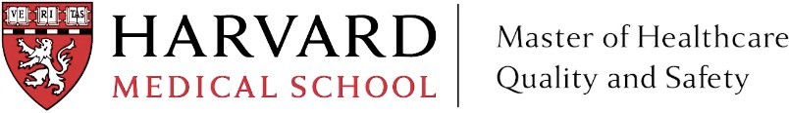

Position Summary
The Curriculum Assistant for the Master’s in Healthcare Quality and Safety Program (MHQS) supports the planning and delivery of courses within the MHQS curriculum. The Curriculum Assistant works in coordination with the Postgraduate Medical Education unit within the Office of External Education to manage course materials, update learning management systems, monitor student progress throughout the course, teach sessions and workshops if requested, and provide support for course logistics.

Position Description
This position is designed to support teaching and learning within the MHQS program by developing and applying appropriate teaching techniques which create interest, understanding, and enthusiasm amongst students. The Curriculum Assistant is tasked with engaging in ongoing curriculum review, including class content and materials, as well as managing the class experience and communication with students. There may be opportunities for independent teaching, grading, and assistance with assessments.

The Curriculum Assistant will also undertake a range of administrative responsibilities to support the courses and engage faculty. We anticipate that this position will be approximately 6-10 hours per week during each semester that a course is running.

This position would be ideal for a candidate with an interest in healthcare quality and safety and/or medical education. The Curriculum Assistant role provides the opportunity to work closely with program and course directors and learn from their expertise.

Main activities and responsibilities
- Support the teaching objectives of the MHQS program by assisting with the delivery of lectures, workshops, and other and other forms of administrative support.
- Assist with grading throughout the course and provide feedback to students on assignments if requested by the course director
- Engage in teaching or the facilitation of tutoring sessions if requested by the course director and/or program director
- Coordinate and manage guest speakers for the course
- Host class via Zoom and utilize Zoom features to facilitate class
- Monitor student attendance, participation, and progress in the course
- Provide supervision to students, giving advice on study skills and helping with learning problems.
- Identify the learning needs of students and define learning objectives.
- Help facilitate workshops, office hours, and one on one meetings with faculty
- Organize course materials (readings, videos, lecture slides) and post to Canvas in advance of class
- Assist with the compilation of final grade calculations
- Schedule student meetings and review sessions outside of class, if requested
- Manage and update the course Canvas site
- Communicate any student issues or concerns concisely and promptly with the course director
Additional Key Skills:

Communication
- Routinely communicate ideas to those with limited knowledge as well as to peers using high level skills.
- Understand how to adapt communication style to a diverse range of students and program stakeholders

Teamwork
- Act as a responsible team member, leading where agreed, and develop productive working relationships with students and faculty.
- Coordinate the work of colleagues to identify and respond to student needs.

Initiative, problem solving and decision making
- Identify the need for developing content or structure of modules with colleagues and make proposals on how this should be achieved.
- Develop ideas and find ways of disseminating and applying the result of scholarship. Collaborate with colleagues on the implementation of assessment procedures.
- Tackle issues affecting the quality of delivery within the scope of own level of responsibility, referring more serious matters to others as appropriate.

Requirements
- Advanced degree in healthcare
- Interest in or direct experience with healthcare quality and safety
- Knowledge of higher education instruction and learning theory
- Excellent written and verbal communication skills
- Ability to demonstrate independent and self-managing work style
- Ability to engage with a diverse group of learners and adapt to a variety of learning styles
- Ability to maintain discretion with sensitive information

Contact Katherine_king@hms.harvard.edu for more information

